

version 6.5

Contents:
www.nscl.msu.edu/lise  dnr080.jinr.ru/lise | East Lansing  January-2004

1. ISOL method 2
1.1. Mass separator “MASHA” 3
1.2. Charge states 5
2. Other 6
2.1. Electric dipole: separation plane 6
2.2. Wedge angle dialog 6
2.3. MSP-144 modification 6
Acknowledgements 6
Reference: 6

1 ISOL method
The code does not simulate processes in the ISOL-target (number of produced fragments, diffusion, extraction time etc). The new method is a combination of the so-called ISOL method of production and separation of radioactive nuclei with the classical method of mass analysis. This new method named “ISOL-method” has been incorporated to estimate fragment transmission through a spectrometer, and help with spectrometer tuning. Using LISE++ graphical utilities the user can observe spatial and energy distributions after any optical block.
The ISOL mode can be set in the “Production mechanism” dialog (menu “Options”). The buttons “Target”, “Stripper”, and “Setting fragment” are absent in this mode. The user can only set parameters of the projectile and choose a spectrometer configuration. Nuclei produced in nuclear reactions are emitted from an ECR ion source at energy E = q U, where q is the ion charge of nuclide, and U is the voltage in kV. For this mode the new possibility of entering the energy in kV has been developed (see Fig.1).
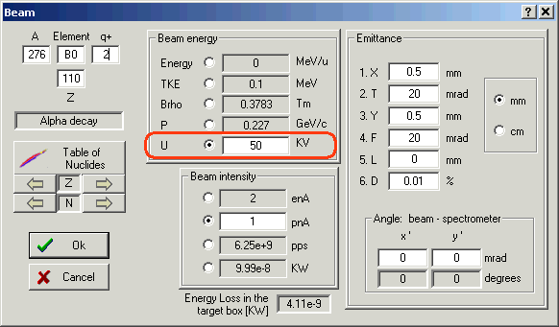
Fig.1. The “Beam” dialog.
The next step is the calculation of spectrometer settings for the chosen projectile using the button in the toolbar or calling the command “Calculate the spectrometer for setting ion” from the menu “Calculations”. To calculate an ion rate and get the window of transmissions the user has to click the right button of the mouse on the isotope of interest in the chart of nuclides. The energy of nuclide is calculated based on the voltage value U entered for the projectile and its ionic charge. It is assumed initially that the intensities of other fragments are equal to the intensity of the projectile. Instead of the “cross section” value in other modes the ISOL mode operates by defining an “Intensity coefficient” (see Fig.2). However the user can change the intensity coefficient using the “Cross sections” dialog or load a coefficient file through the “Cross Section file” dialog. The intensity coefficient should be proportional to the production cross section of the given nuclide and the coefficient of extraction from ECR. It is possible to use the PACE4 code (or “LisFus” model) to estimate the production cross sections. The file with calculated cross sections can be loaded as intensity coefficients using the “Cross section file” dialog (see documentation for version 6.4).
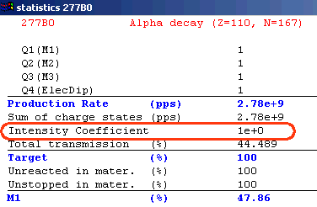
Fig.2. The transmission statistic window.

2 Mass separator “MASHA”
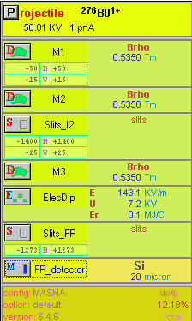
Fig.3. MASHA separator
set-up window.
The configuration file of the mass separator MASHA [Oga03] operating in “ISOL-mode” has been created and incorporated in the LISE++ installation package:
LISE++ file: | Files\examples\MASHA.lpp
Configuration file: | Config\Dubna\MASHA.lcn
The separator MASHA set-up window and its scheme are shown in Fig.3 and Fig.4. The MASHA configuration file provides by calibration files of magnetic dipoles that help the user to tune the mass separator.
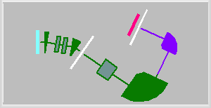
Fig.4. LISE++ scheme of
MASHA separator.
Envelopes of ²⁷⁶B0¹⁺ and ²⁷⁵B0¹⁺ nuclides through the MASHA mass separator tuned on the ion ²⁷⁶B0¹⁺ are shown in Fig.5. The projectile initial emittance used in that calculation was the following: x=y=0.5 mm, θ=ϕ=20 mrad, dp/p=0.01%. Some examples of fragment transmission calculation under different initial conditions are presented in Fig.6.
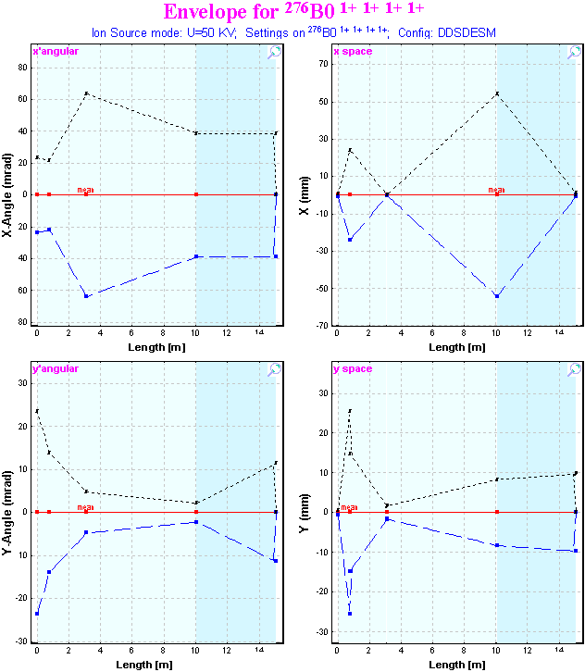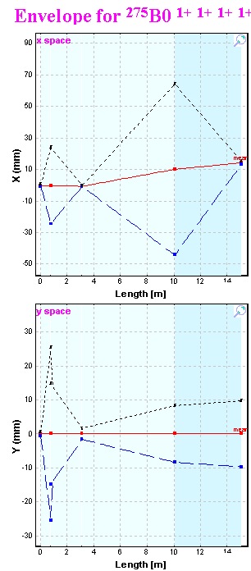
Fig.5. Envelopes of ²⁷⁶B0¹⁺ and ²⁷⁵B0¹⁺ nuclides through the MASHA mass separator tuned on the ion ²⁷⁶B0¹⁺.
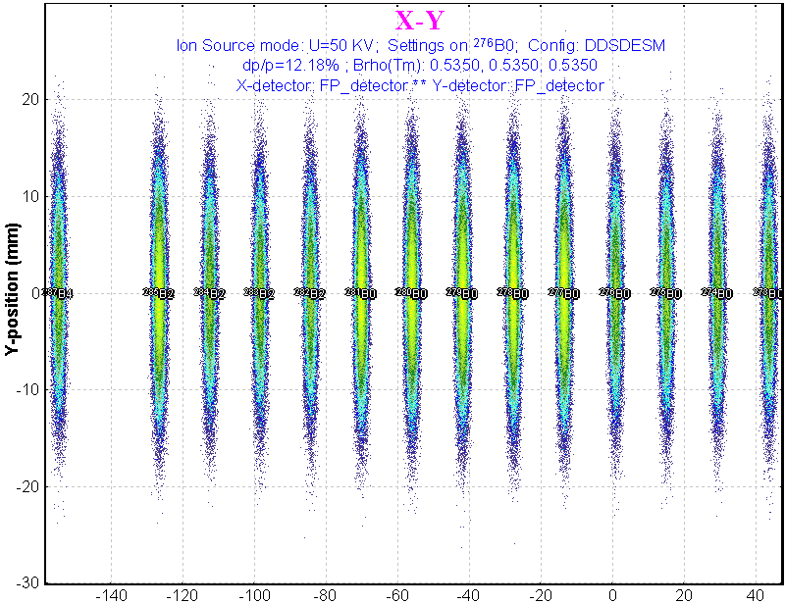  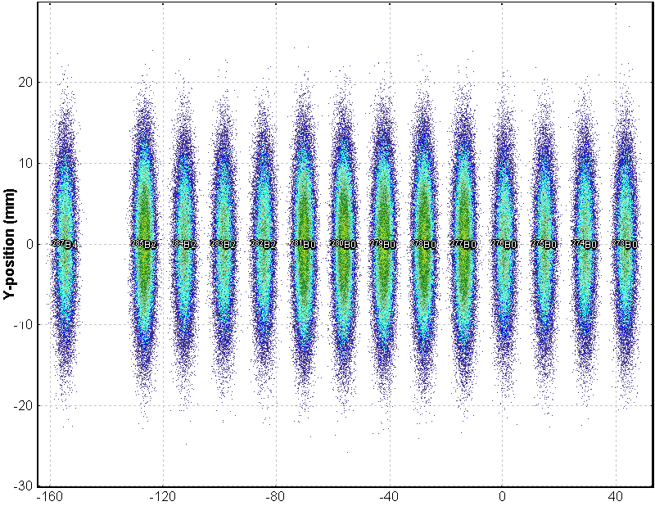  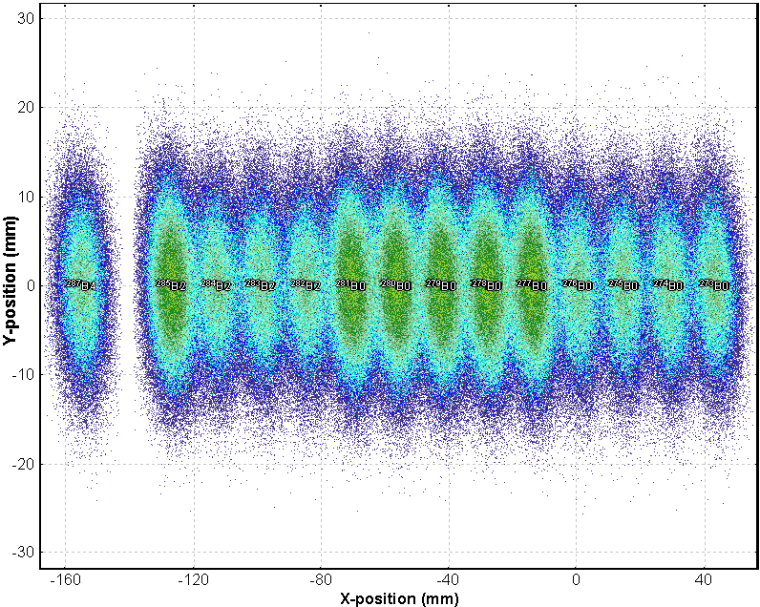 | Fig.6. Two-dimensional identification plots of nuclides transmitted through the mass separator and registered by the final focal plane position-sensitive detector. The spectrometer is set to ²⁷⁶B0¹⁺.  The top figure corresponds to the projectile initial emittance x=y=0.5 mm, θ=ϕ=20 mrad, dp/p=0.01%;  the middle figure to x=2.5mm, y=0.5 mm, θ=ϕ=20 mrad, dp/p=0.01%;  the bottom plot to x=y=0.5 mm, θ=ϕ=20 mrad, dp/p=0.05%.

3 Charge states
It is recommended to turn the “Charge state” option off, because the output of ions with a charge more than 1+ is small in this energy region (some tenth of KeV). Moreover, other charge states will be suppressed by the spectrometer, which is tuned on ions with 1 +. The next example proves this statement. For this purpose it is necessary to turn off all slits and turn on the “Charge state” option. For the ISOL method the code assumes that the output of ions with charge q=(n+1)+ is 10 times less than the output of ions with charge q=n+ (see Fig.7). In this case ions with different charge will be easily differentiated in the plots (see Fig.8). In the figure it is visible that the ions with q=2 + are located away from q=1+ by two meters, much greater than the sizes of the detector. Moreover charges with q >1 will not go through the first dipole. It is easy to check this statement. | 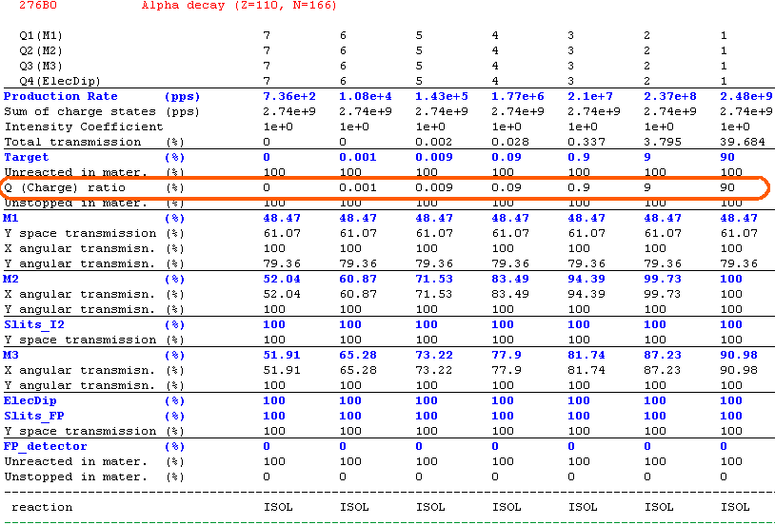  Fig.7. The transmission statistic window.  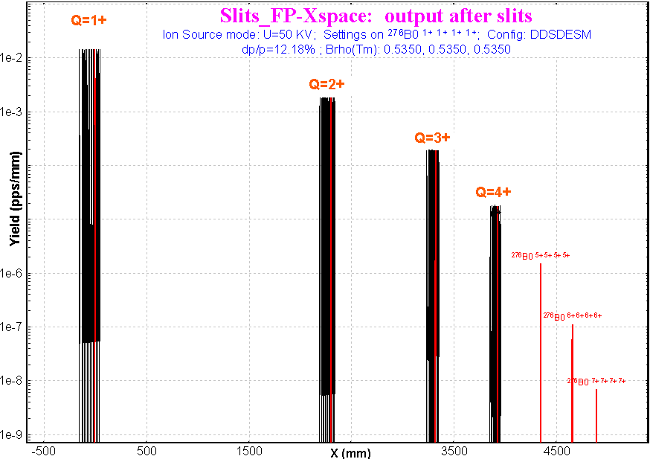  Fig.8. Horizontal spatial distribution of ions in the final focal plane of  mass separator MASHA. Spectrometer settings are shown in the figure.

4 Other

5 Electric dipole:
separation plane
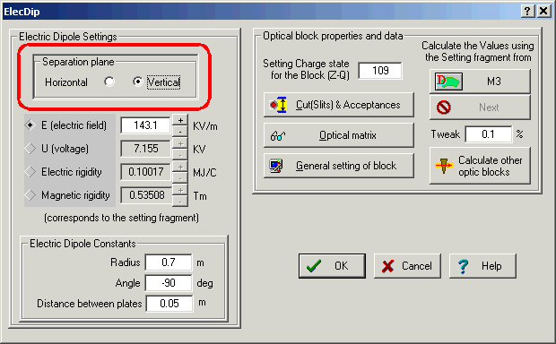
Fig.9. The “Electric dipole” dialog.
A “Separation plane” frame has been added to the “Electric dipole” dialog (see Fig.9) to select the plane where the electric rigidity selection is applied (E-plane). The magnetic rigidity selection is applied to the perpendicular plane (M-plane). This modification was introduced because of a specific case in the MASHA spectrometer where after the electrical dipole both dispersions in vertical and horizontal planes are not equal to zero.

6 Wedge angle dialog
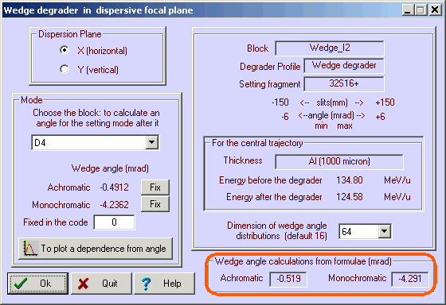
Fig.10. The “Wedge angle” dialog.
Wedge angle calculations basing on formulae have been added to the “Wedge angle” dialog (Fig.10). The code calculates the transfer matrix between the wedge block and the point chosen in the dialog to get the spatial magnification and dispersion coefficients. This method of wedge angle calculation does not take into account materials which can be located between the wedge and the final point.

7 MSP-144 modification
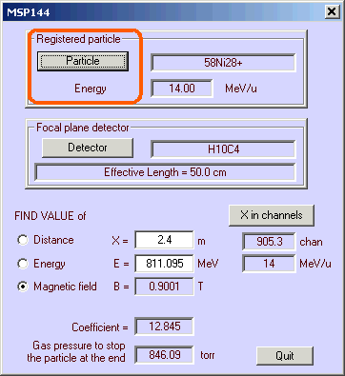
Fig.11. The MSP144 dialog
The possibility to input a projectile energy in the MSP144 dialog was developed (see Fig.11). The algorithm to search the magnetic field B from E and X has been corrected.

Acknowledgements
The authors gratefully acknowledge Dr.V.Shchepunov (Dubna, Oak Ridge) for help with the development of the MASHA spectrometer configuration for LISE++.

Reference:
[Oga03] Yu.Oganessian et al., NIM B 204 (2003) 606-613.

